**Analysing Gender Disparity in Nollywood: Utilizing Four Criteria for Evaluation.**

A captivating exploration using data analysis techniques to visualize and uncover insights into gender inequality in Nollywood. 

**BALOGUN OLUMIDE CHRIS, March 2024 krisbalo11@gmail.com Tel: +2348065060691**

**K Tel**

My friends and I went to the cinema to watch one of the most anticipated movies we had been eagerly awaiting. While enjoying the film with a group of friends, some of the women in our group expressed their frustration with how Nollywood (the Nigerian film industry) tends to objectify female actors, portraying them primarily as sex symbols. They pointed out that in many Nollywood movies, a female actor is often expected to have an appealing body shape, with well-defined curves, large buttocks if possible, and an attractive breast size that commands attention.

After the movie, we continued our conversation, and my female friends posed some meaningful and critical questions to the men in our group:

1. Why are female actors stereotyped?
2. Are female actors and filmmakers objectified because the industry is dominated by men?
3. Why does Nollywood infuse elements of romance into its movies?
4. Why are females underrepresented in Nollywood?

They concluded that women should not be seen as objects but as creative individuals full of talent, capable of significantly contributing to the industry's development. These questions and conclusions ignited a spark within me, prompting me to delve into data analytics to answer my friends' questions and determine if gender inequalities exist in Nollywood and to what extent.

With these questions on my mind, I set out to use Netflix Nigeria's data between 2013 and 2023 to uncover answers. Over a period of three weeks, I watched over 90% of the movies and TV shows available on Netflix Nigeria, having already seen 50% of the content. This thorough examination allowed me to substantiate my discoveries with concrete examples and observations.

**To answer these questions, I focused on four criteria:**

1. **Analysing the Movies and TV Shows Directors**:
   * Evaluating the total counts and proportion of male against female directors.
   * Identifying the top 5 male and female directors.
2. **Analysing the Movies and TV Shows Producers**:
   * Evaluating the total counts and proportion of male against female producers.
   * Identifying the top 5 male and female producers.
3. **Applying the Bechdel Test**:
   * Evaluating the rate of success and failure of the Bechdel Test.
   * Analysing how many female-directed or produced movies passed the test.
4. **Analysing the Total Count and Proportion of Male against Female Lead and Co-lead Roles**.

**Let's break it down.**



This concise text outlines the significant stages involved in the project through a simple yet informative graphic. However, for some, reading textual descriptions might be more accessible than interpreting graphical representations of data wrangling processes.

1. Data Collection: Acquired via Web Scraping.
2. Preprocessed data in Excel.
3. Data Cleaning: Rectifying spelling errors, eliminated blank entries, and omitted irrelevant columns specific to the project's scope.
4. Data Transformation: Altered the data to facilitate analysis.
5. Data Integration: Consolidated information from various sources into a cohesive dataset.

As with all data analytics projects, the process begins and ends with the data. My next focus will be on data exploration and validation as we undertake this critical analysis of gender disparity in Nollywood, utilizing four specific criteria for evaluation.

**Let's first understand Nollywood and how it has contributed to the Nigerian economy.**

**Act 1: Introduction**

Nollywood, Nigeria's film industry, plays a crucial role in the economy by offering numerous employment opportunities. It is the world's second-largest film producer, with UNESCO reporting around 2,500 movies and TV shows produced annually. Since its inception in the early 1990s, Nollywood has grown exponentially, becoming a significant cultural and economic force in Nigeria and beyond. From 2017 to 2020, the industry saw an impressive 477.6% increase in annual production, reaching 2,599 productions in 2020.

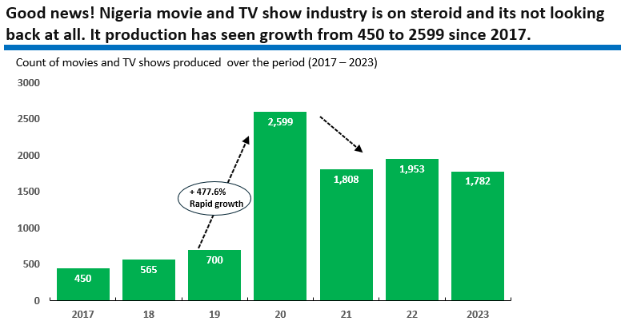

Over the past two decades, Nollywood's steady growth has led to its contribution of approximately 1.3% to Nigeria's GDP in 2021. According to PwC, this contribution was 2.3% of the GDP, equivalent to around $600 million. Future projections suggest that Nollywood is on track to achieve an annual value of approximately $1 billion.

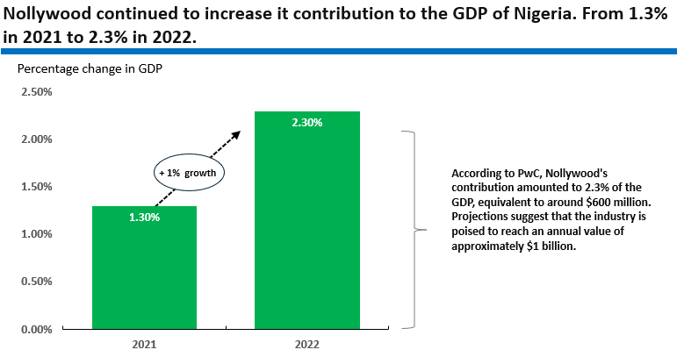

Nollywood is a powerhouse in the Nigerian economy, driving employment, revenue generation, technological advancements, cultural export, and economic diversification. Its impact extends beyond the film industry, influencing various sectors and contributing significantly to Nigeria's economic development.

**Let’s examine whether there’s gender disparity in Nollywood and to what extend is the gap using the following four criteria for evaluation.**

**Act 2: Analysing the Movies and TV Shows Directors**

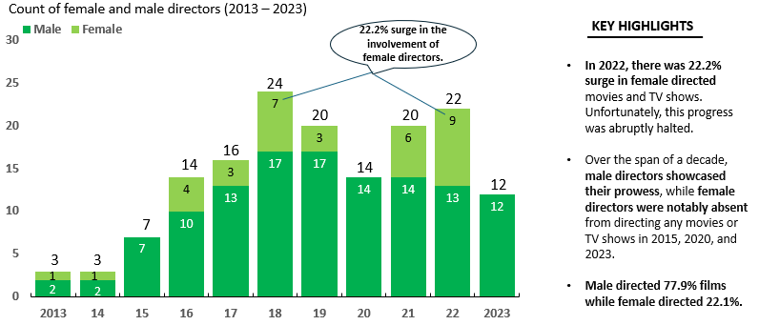**Scene 1: Evaluating the total counts and proportion of male against female directors.** Despite a modest increase in 2022, female directors continue to be underrepresented in the movie industry. The male lead all the way.

**Scene 2: Evaluating Gender distribution across movie and TV show genres directed by female and male over time.**

Male directors excel overall, yet female showcase their strengths in crime, documentary, and drama genres.

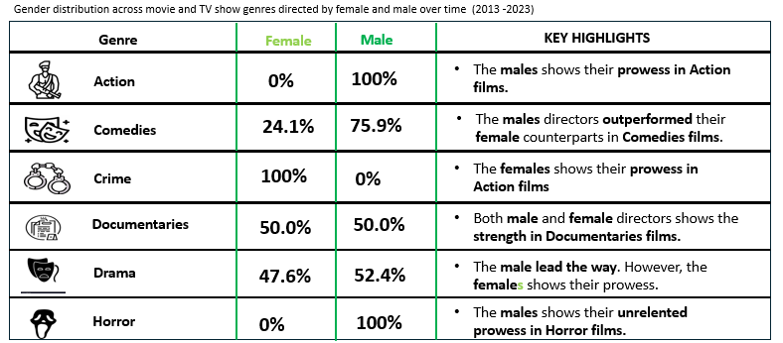

**Scene 3: Top 5 highly skilled female and male directors.**

Remarkable Disparity: The striking dominance of the Top 5 male directors over their female counterparts in the film industry.

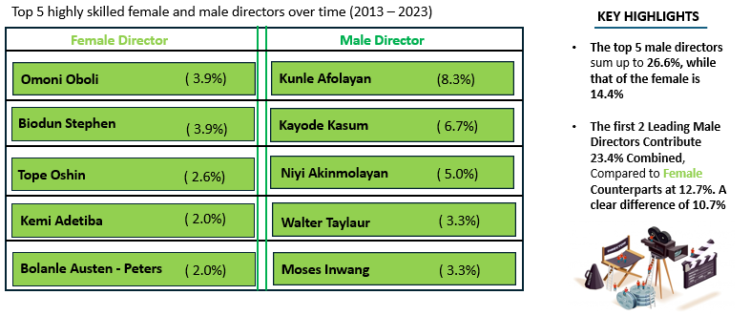

**Act 3: Analysing the Movies and TV Shows Producers**

**Scene 1: Evaluating the total counts and proportion of male against female producers.** Male producers continue to dominate, despite females constituting 42.2% of industry producers, showcasing a significant, noteworthy, and substantial presence.

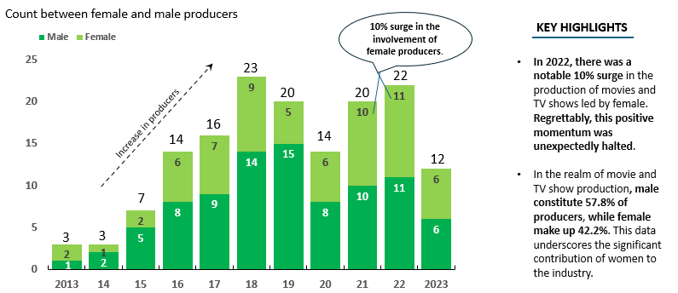

**Scene 2: Evaluating Gender distribution across movie and TV show genres produced by female and male over time.**

In spite of the remarkable achievements of female producers in Crime, Documentary, and Drama genres, their male counterparts persist in maintaining a lead.

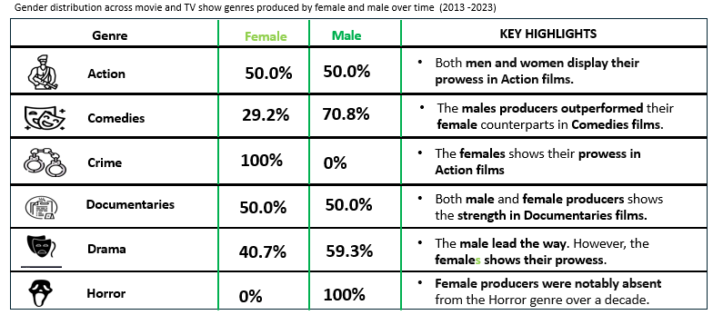

**Scene 3: Top 5 highly skilled female and male producers.**

Significant Imbalance: The marked prominence of the top five male producers in comparison to their female counterparts within the movie industry.

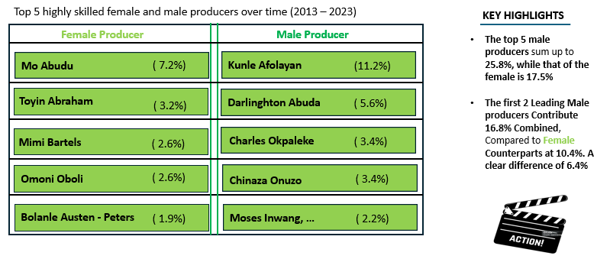

**Act 4: Applying the Bechdel Test**

**Scene 1: Evaluating the rate of success and failure of the Bechdel Test.**

It’s evidence that the majority of movies and TV shows do not pass the Bechdel test. The failure rate significantly surpasses the success rate.

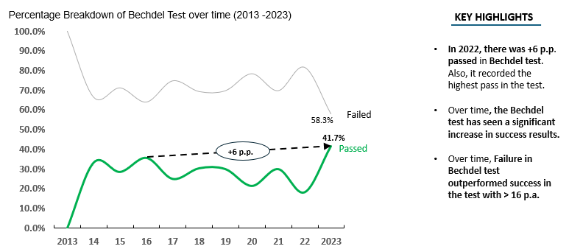

In 2018, the failure rate of the Bechdel test surged by 433.3%, and also revealing a noticeable 44.2% gap between failure and success rates over a decade.

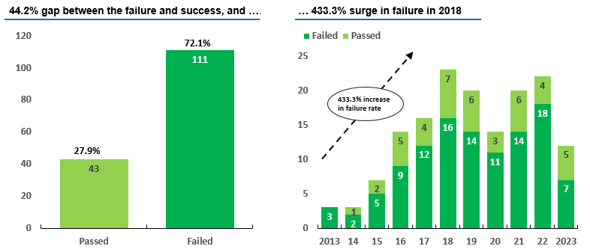

**Scene 2: Analysing how many female-directed movies or TV shows passed the test.**

It's clear that the most of movies and TV series Directed by Females do not meet the criteria of the Bechdel test, with the rate of failure far surpassing the rate of success.

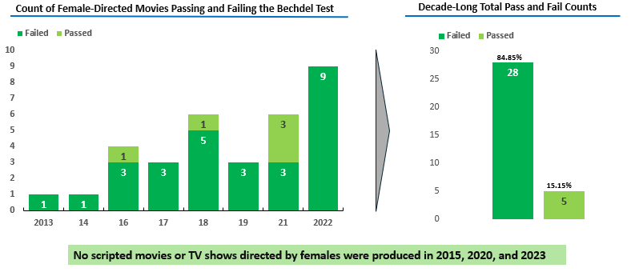

**Scene 3: Analysing how many female-produced movies or TV shows passed the test.**

It's clear that most movies and TV shows Produced by Females do not pass the Bechdel test, with the failure rate significantly exceeding the success rate.

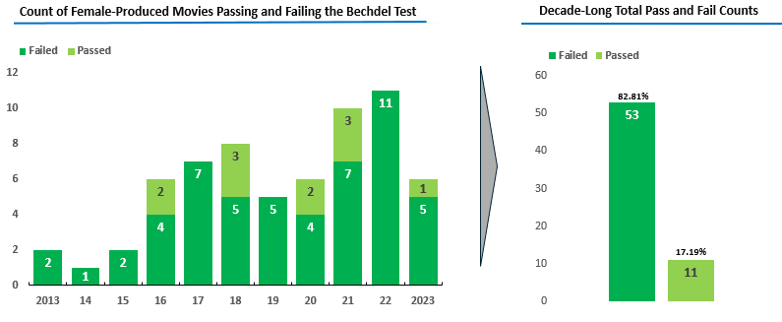

**Bechdel Test Observations**

* **Widespread Imbalance**: A considerable number of movies and TV shows fail to meet the Bechdel test criteria, which assesses the representation of women in the film Industry.
* **Comparative Rates**: The proportion of productions that do not satisfy the Bechdel test notably exceeds those that do, highlighting an area for improvement in gender representation.

**This crucial reminder underscores that while the Bechdel test provides a valuable starting point for discussing gender representation in film, it's essential not to rely solely on it when assessing a movie's quality or the depth of its characters. Genuine diversity and complex female characters are vital for achieving a truly equitable portrayal of genders in the film industry**.

**Act 5: Analysing the Total Count and Proportion of Male versus Female Lead and Co-lead Roles.**

**Scene 1: The percentage breakdown of Lead and Co-lead roles.** Female lead roles have seen a significant decline in the past 3 years. However, over the decade, the total count of female lead roles remains equal to that of male**.**

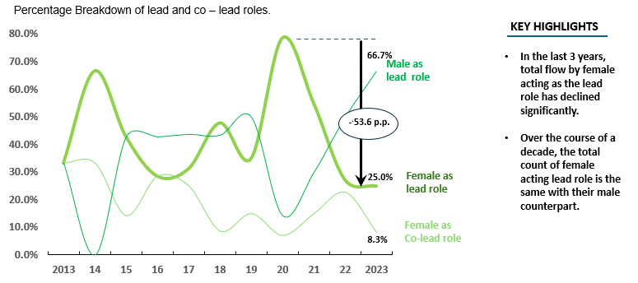

Amazing! Gender equality at display, and also increase in the lead and co-lead role in the movies and TV shows from 2013 through 2018**.**

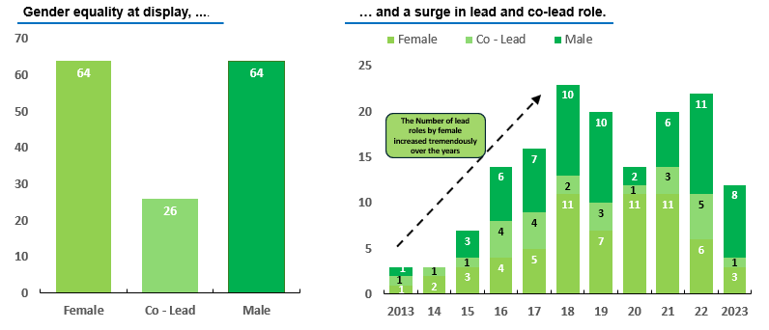

**Having established that gender disparity is prevalent in Nollywood and at an alarming rate, it is crucial to address this challenge urgently. Let's explore ways to tackle gender disparity and promote gender equality in Nollywood.**

**Recommendations:** Call for Action

**6 Strategic Foci to** **Address Gender Disparity and Promote Gender Equality in Nollywood.**

**1. Enhancing Representation, Visibility, and Embracing Diversity**

* Promote gender inclusivity within Nollywood by fostering greater participation and representation of female in all aspects of the industry, including on-screen roles and behind-the-screen positions.
* Encourage and empower female actors, directors, producers, and writers to contribute their unique perspectives and talents, enriching the diversity and creativity of Nollywood productions.
* Champion narratives that celebrate the multifaceted experiences, accomplishments, and obstacles faced by females. Illuminate their significant contributions to the industry.
* Create a movie and TV show landscape that fosters inclusivity and empowerment by activity challenging stereotypes and presenting females in multifaceted roles. Steer clear of perpetuating negative stereotypes or confining females to narrow, predefined roles.

**2. Empowering Networks and Mentorship Initiatives**

* Establish networks to facilitate connections among females, fostering the sharing of experiences and collaborative opportunities.
* Organize networking events specially designed for upcoming female movie and TV show makers to connect with industry professionals, serving as catalyst for collaborations and paving the way for creative and valuable opportunity.
* In mentorship relationship, females supporting one another, cultivate a nurturing environment where they exchange experiences, insights, and guidance.

**3. Advancing Industry Advocacy and Awareness**

* Champion gender - inclusive policies within Nollywood advocating for equitable representation in policy and decision – making bodies.
* Promote awareness of gender disparities within the industry and advocate for industry participants, and policy – makers to prioritize gender equality.

**4. Crafting Stories with Gender Sensitivity**

* Champion narratives that empower female, challenge societal norms, and address critical issues such as gender – base violence.
* Engage in collaborative storytelling with female writers, producers and directors to create authentic narratives that resonate with a diverse audience.

**5. Empowering Financial Assistance**

* Facilitate financial assistance by way of offering grants, funding opportunities, tax incentives, and investment schemes specially tailored to empower female movie and TV show makers in bringing their project to fruition.

**6. Commendable Accomplishments, Distribution and Promotion**

* Honoring Excellence by celebrating and recognizing exceptional contributions from female writers, producers, directors, actors, ...
* Engaging various distribution channels and promotional tactics to assist female movie and TV show makers in securing distribution and also aid in promoting their projects.

**In conclusion**

This report provides a thorough examination of Netflix Nigeria's data concerning Gender Disparity in Nollywood, empowering stakeholders to make well-informed decisions and implement strategies aimed at enhancing gender equality within the industry. Through the cultivation of an inclusive atmosphere, the acknowledgment and celebration of females’ achievements, and the active challenge of stereotypes, we can cultivate a film industry that is not only more equitable but also more vibrant and enriching for all involved.

**See how this was done from the Comprehensive Presentation Slides**

Although this report is lengthy, it provides a concise overview of the steps I took during the project. For a detailed account of the project's development, you can view my presentation slides on LinkedIn at <https://www.linkedin.com/in/olumide-balogun1/> or GitHub at <https://github.com/olumidebalogun1>.

**Contacts - BALOGUN OLUMIDE CHRIS.**

**Email: krisbalo11@gmail.com Tel: +234(0)806506069**